Lions Roar
We Serve
June 2022 Newsletter

Hello Fellow Lions----
Website: You can always go to the Sharon Lions Website to also see what is happening with the club.
Blood Drives – Our next Blood Drive will be July 5th. Please mark this on your calendar.
Help is always needed at the Blood Drive.
We will be bringing back the sandwiches and cookies at our July Blood Drive.
Sharon Lions Dues - Your Sharon Lions dues are due at this time. Please get your money to Lion Stephanie. Her address is Stephanie Smith, 150 W School St., #119, Sharon, WI 53585.
Scholarships –The Big Foot students that received scholarships from the Sharon Lions are Andrew Sachs and Ashley Lohse.
Lions Roar Schedule- All but 2 have paid for the month that they have selected to sponsor. Please get your $21 to Lion Stephanie.
Installation of Officers – The installation of officers for 2022 – 2023 took place at Big Foot Inn on June 26th. District Governor Larry Redlin did the installation. They are as follows: President Lion Jessica Square, 1st VP Lion Jerry Olson, 2nd VP Lion Jeff Crump, 3rd VP Lion Maelynn Schnurr, Tail twister Lion Carol Frederick, Treasurer Lion Stephanie Smith, Secretary Lion Pam Schutt, Lion Tamer Lion Bill Dawson, Directors are Lions Sherrie Dawson, Lion Denny, Lion Denise Gibbons and Lion Debbie Wojcik. Global Service Team Lion Sara Andrus and Membership/ part of the Secretary job is Lion Jerry Gibbons.
The new officers start in July. Here are a few pictures from that night.
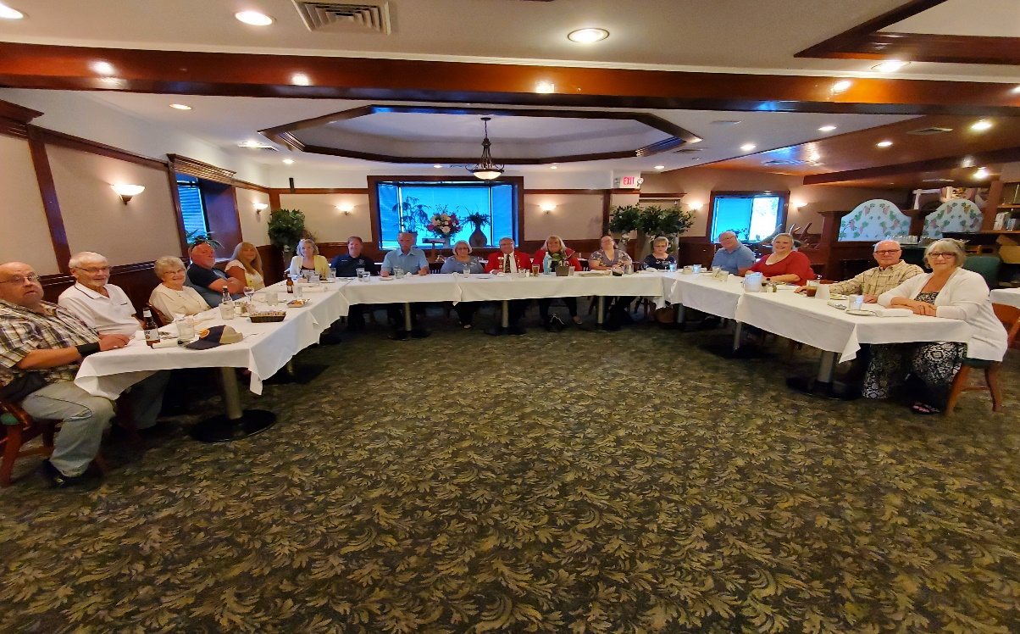
The whole group waiting for their dinner.
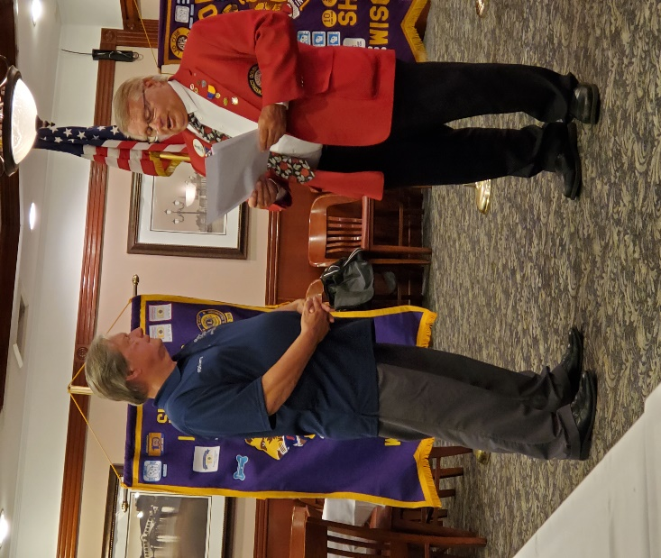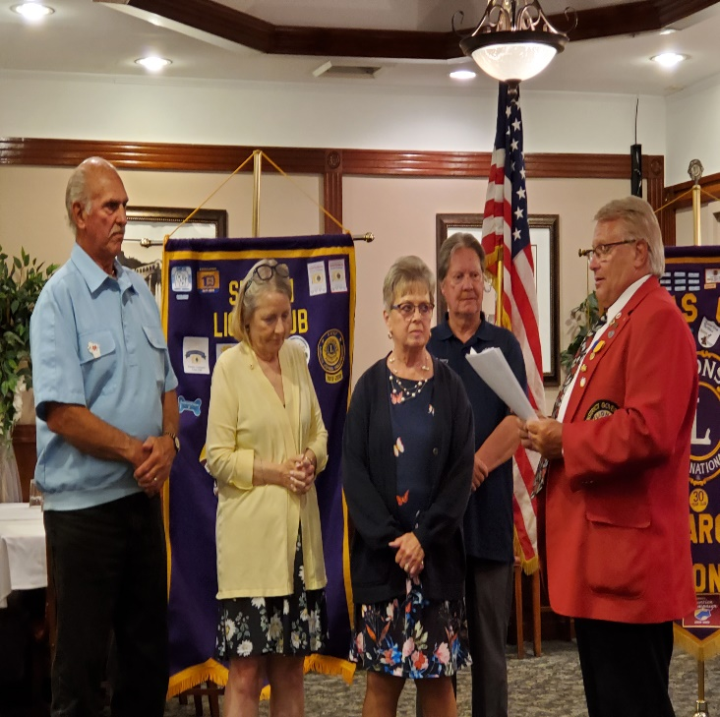
Installing Lion Jerry Gibbons as Membership Chairperson and Board of Directors.
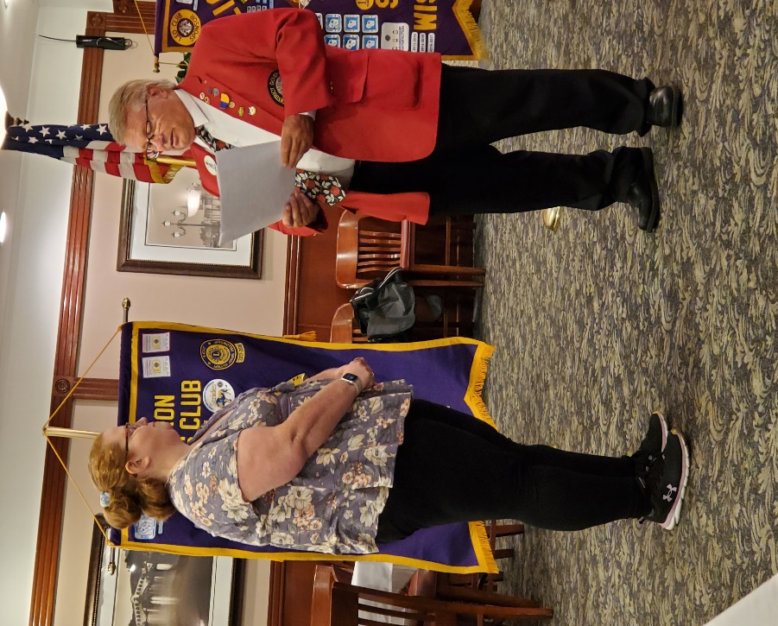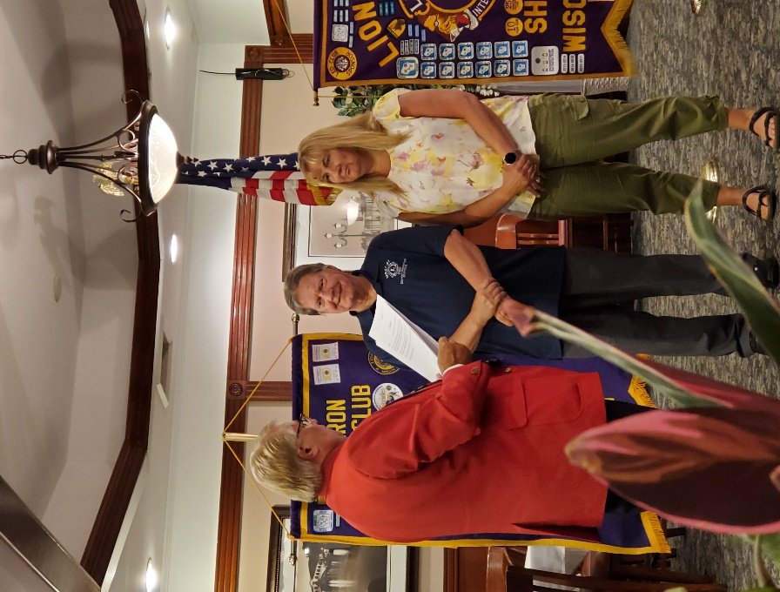
Installing the president and the 2 people doing the secretary’s job.
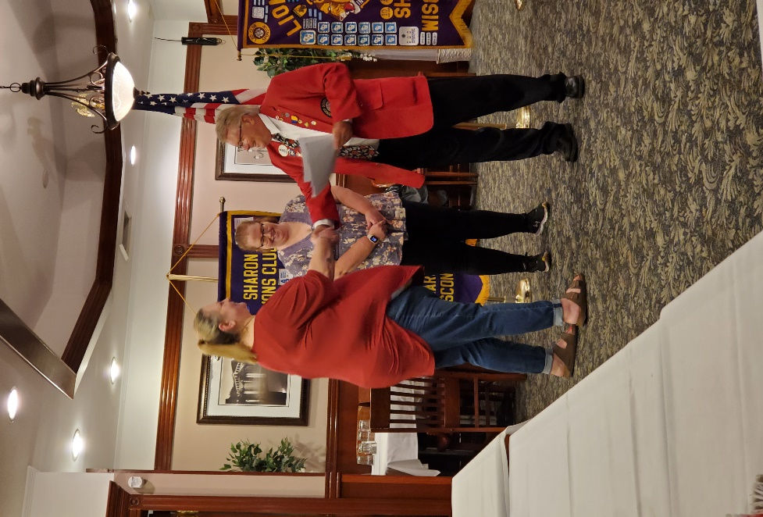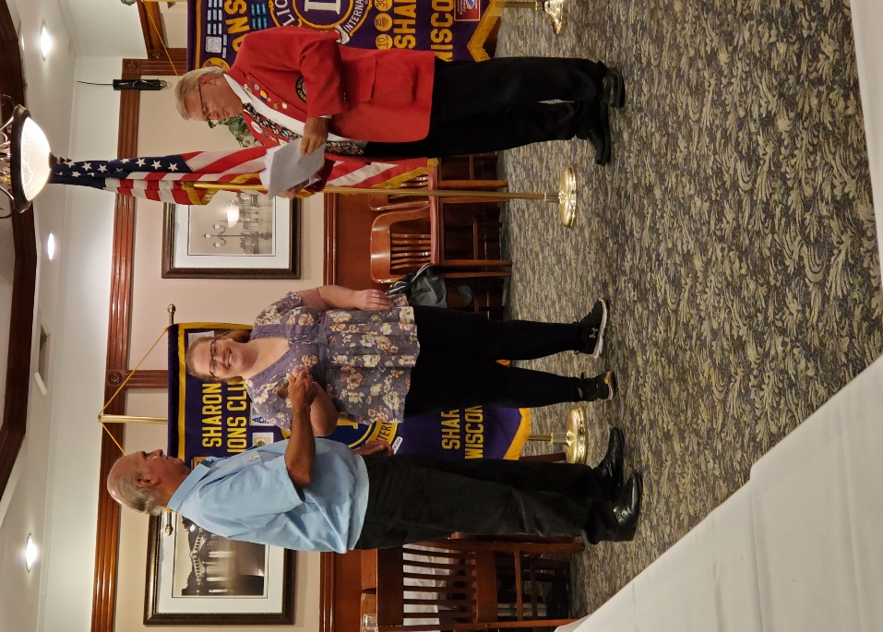
Installing the treasurer and passing the gavel..
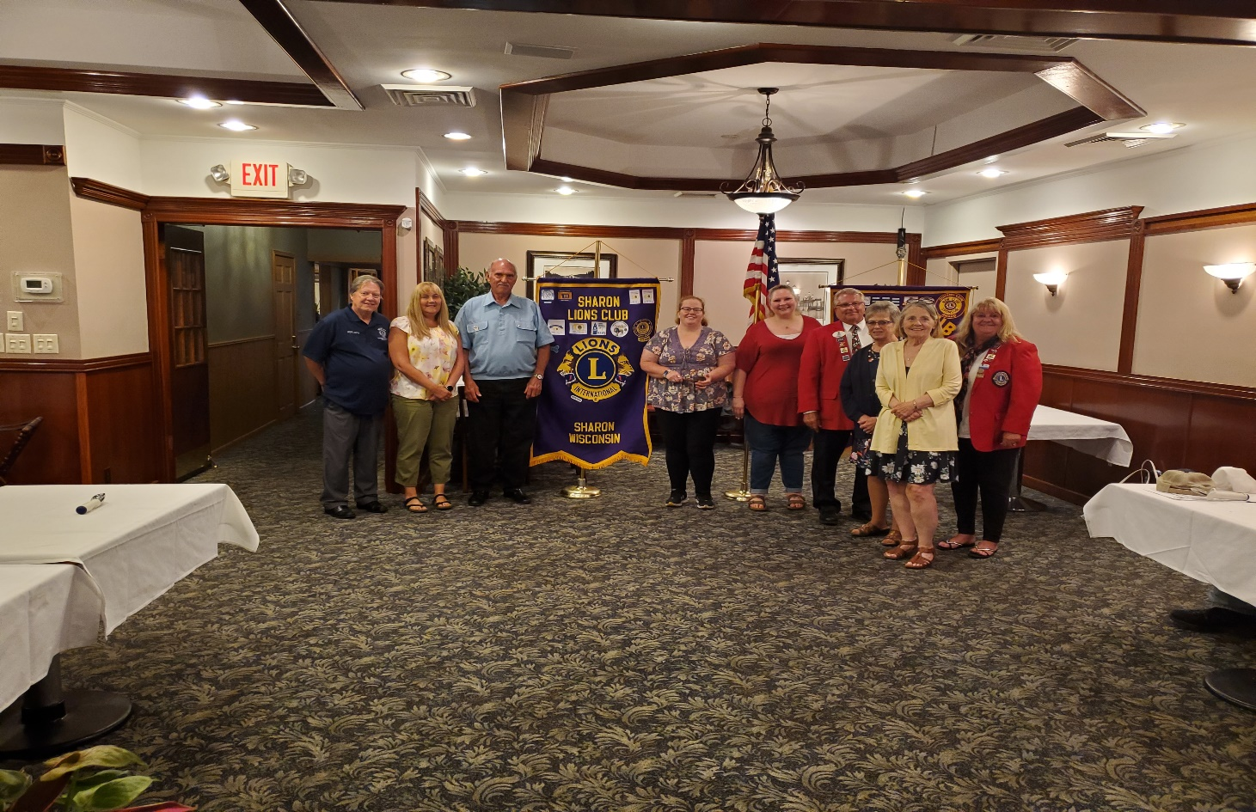
All Lion members.

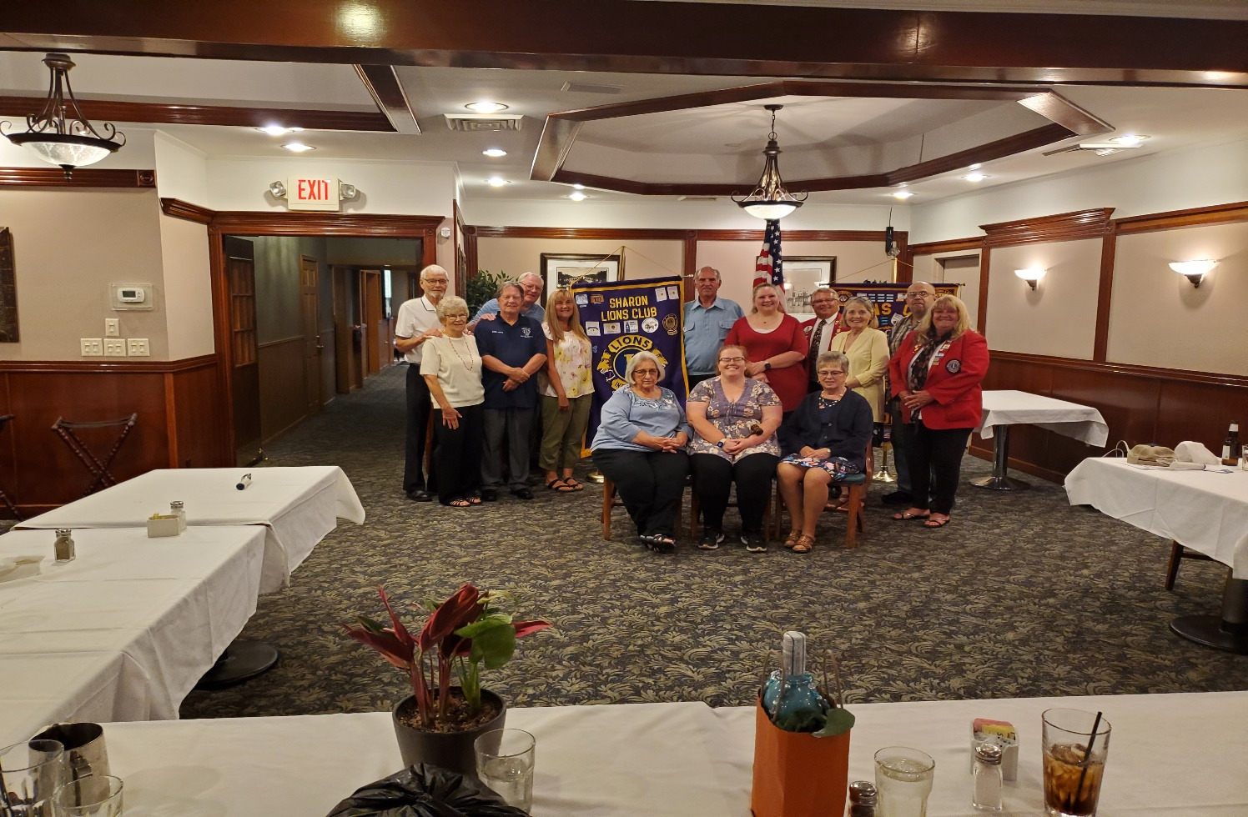
The District Governor thanked the Sharon Lions for inviting him and his wife (Patti) to the installation of officer’s dinner. He likes coming out this way.
July 4th - We will have a booth, but we need WORKERS. Lion Denny has reserved the Dunk Tank. We will serve corn (but raise the price to $3), peanut butter and jelly sandwiches, popcorn, water and pop. Please see if you can volunteer for an hour or 2 so NO ONE HAS TO WORK ALL DAY.
We will also have the dunk tank at the park. Help is needed there also. We would like some kids to chase balls at the dunk tank. We will also need help collecting the money and working in the booth.
Remember in your prayers: Remember in your prayers Lion Ray Lowry and Lion Bob DePiero and his wife, Linda Lions Denise Gibbons, Denise Hegg and Debbie Wojcik.
Birthdays –There are 3 birthdays in June. The first one is Lion Denise Gibbons on June 9th, the next one is Lion Ray Ennis on June 24th and the last one in June is Lion Jessica Square on June 29th. There are 3 birthdays in July. The first one is Lion Denise Hegg on July 9th, the next one is Lion Jerry Olson on July 18th and the last one is Lion Dennis Frederick on July 30th.
Upcoming events –
July 4th, 2022 – Parade and food booth at the park
August 23, 2022 – Lions Meeting at the Coffee Cup at 6 PM.
If you have anything for the Newsletter, please get it to Lion Sherrie Dawson. Her e-mail is e and her mailing address is 241 Walworth St., Sharon, WI. 53585. You can also call her at 262-736-4964.
We would like to Thank Lions Bill and Sherrie Dawson for sponsoring the Lions Roar in June.
Lions Roar is sent to you by Lion Sherrie Dawson

