Lions Roar
We Serve
December 2021 Newsletter

Hello Fellow Lions----
The monthly meeting of the Sharon Lions Club was not held in December. Instead, we had the Breakfast with Santa at the Christ Lutheran Church.
We will not be having a meeting in January. Instead, we will be having a Christmas Party at the Big Foot Inn. There are more details later in the newsletter.
Website: You can always go to the Sharon Lions Website to also see what is happening with the club.
Blood Drives – Our next Blood Drive will be January 4, 2022. It will be held at the Christ Lutheran Church.
Help is always needed at the Blood Drive.
District Convention - The 27A1 District Convention will be held on January 14th – 16th. It will be held at the Grand Geneva Resort. To register you must go on line. It is not to late to register for the convention. Our President Lion Denny is looking for more club members to go to help support Lion Denise in running for a position for the Lions Camp.
State Convention - It will be held in May at the Grand Geneva as well. Watch for details in the paper
Christmas Party – The annual Lions Christmas Party will be held on January 23rd at the Big Foot Inn. It will start with cocktails at 5 pm and dinner at 6 pm. When we get our choices for the meal, we will let you know. Everyone will pay Lion Stephanie, so that the bill is paid at one time.
There will also be a White Elephant gift Auction after the meal. Start looking for that certain item, whether it be a gag gift or something nice. Everyone enjoys watching the people open their winnings. We are going to ask a few guests.
Lions Roar Schedule- There is 1 month open to sponsor the Lions Roar. That month is November. If you would like to sponsor the Lions Roar for the month of November in 2022, please let Lion Sherrie Dawson know and she will be glad to put you on the list. Sherrie Dawson bsdawson@sharontelephone.com or 262-736-4964.
Breakfast with Santa- The breakfast with Santa was held on December 11th from 7 – 11 at the Christ Lutheran Church. Lion Ed Hayden was our Santa again this year. We had a great turnout of Lions for help that morning. Thank you to all of the Lions for your help.
We also had a great response for the items that were raffled off. Nice job everyone.
I don’t have the figures from the Breakfast with Santa. Hopefully we will have them at the Christmas party.
I will put in a few pictures from that day.
Santa and his helper and just some of the items that were raffled off.
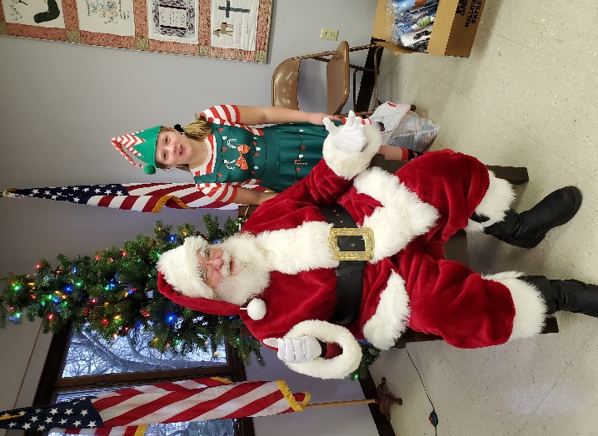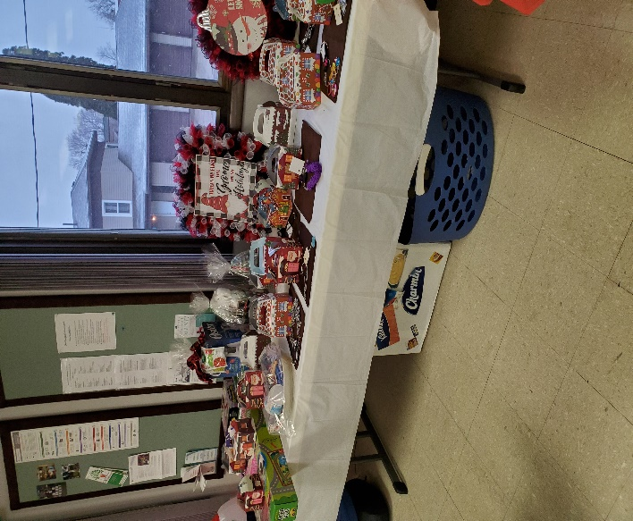

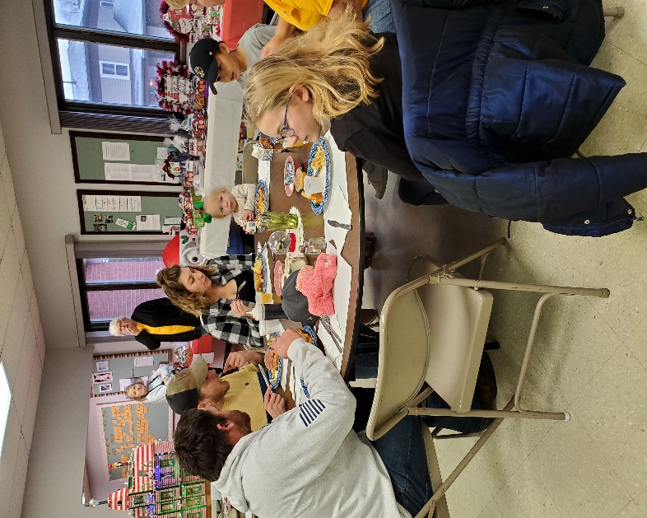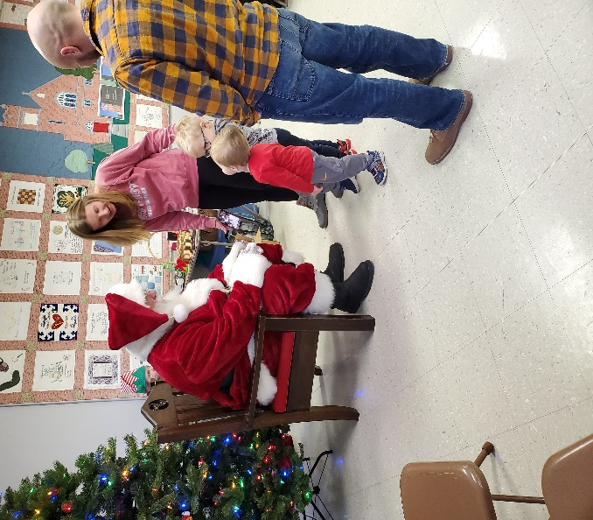
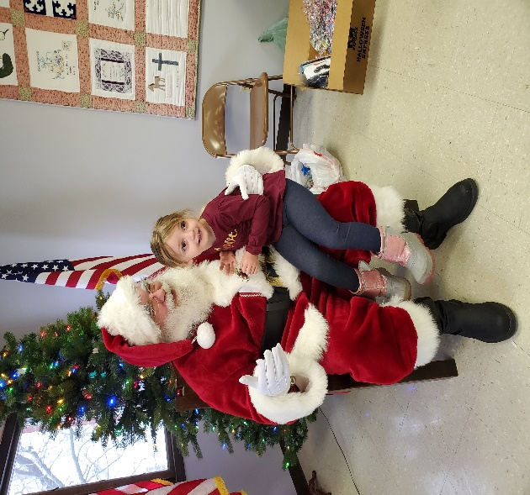
We had a problem with the camera and the printer, so some of the people didn’t get their pictures printed with Santa.
New Member – If you know of someone who would like to join the Lions Club, give them an application, if you have one and tell them that the entrance fee will be waved until December 31st of 2022. This is just for new members.
Deer Hides - Lion Bill Dawson is collecting deer hides for the Lions Camp. Please bring your hides to 241 Walworth St, Sharon. There is a trailer there for you to put the hides on. If you know of someone who has gotten a deer and they don’t know what to do with the hide, tell them to bring them to the Dawson home. Lion Bill has collected about 22 hides and has taken them to Elkhorn.
Officers – President Lion Denny, 1st VP Lion Jerry Olson, 2nd VP Lion Jeff Crump, 3rd VP Lion Jessica Schnurr, Tail twister Lion Carol Frederick, Treasurer Lion Stephanie Smith, Secretary Lion Sue Mullis, Lion Tamer Lion Bill Dawson, Directors are Lions Sherrie Dawson, Lion Sara Andrus, Lion Denise Gibbons and Lion Debbie Wojcik. Global Service Team Lion Sara Andrus and Membership/ part of the Secretary job is Lion Jerry Gibbons
Remember in your prayers: Remember in your prayers Lion Ray Lowry and Lion Bob DePiero and his wife, Linda.
Birthdays – There are 2 birthdays in December and that is Lion Russ Hegg on December 2nd and Lion Carol Frederick on December 12th. There are 2 birthdays in January. They are Lion Jeff Crump on January 2nd and Lion Cecil Butturini on January 21st.
Upcoming events –
January 4th, 2022 – Blood Drive at the Christ Lutheran Church from 1-6.
January 23rd – Christmas Party
If you have anything for the Newsletter, please get it to Lion Sherrie Dawson. Her e-mail is bsdawson@sharontelephone.com and her mailing address is 241 Walworth St., Sharon, WI. 53585. You can also call her at 262-736-4964.
We would like to Thank Joann Kooistra for sponsoring the Lions Roar Newsletter in December.
Wishing everyone a Very Merry Christmas and a Blessed and Happy New Year.
Lions Roar is sent to you by Lion Sherrie Dawson

