Lions Roar
We Serve
September2021 Newsletter

Hello Fellow Lions----
Our President Lion Denny started the meeting by announcing that we have a possible 2 new members. They are Dan & Darren Deja.
Website: You can always go to the Sharon Lions Website to also see what is happening with the club.
Dues: The new year for the dues has started this July. You can pay them to Stephanie Smith 150 W. School St. #119 Sharon, WI 53585. If you are uncertain as to how much your dues are you can e-mail her at stephie.pooh@yahoo.com.
Blood Drives – Our next Blood Drive will be November 2nd from 1-6 pm at the Christ Lutheran Church.
Please mark your calendar for the dates listed above. Help is always needed at the Blood Drive.
Bowling Fundraiser – We had an excellent fundraiser. Our profit was $3,321.20. After having one, we know what to do different next time. There were a lot of donations as well as items to be raffled off.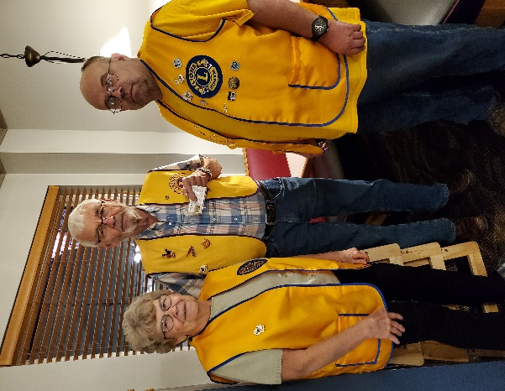Lion Ray Ennis received a diamond centennial pin for having his wife, Mona, become a Lion during the centennial year and Lion Dickie Button received his 3-year pin.
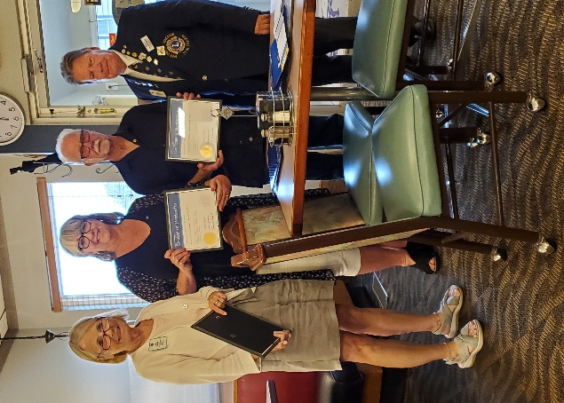I had forgotten to put this picture in last month. Lion Jerry Gibbons and Lion Denise Gibbons sponsored 2 new members. They are Denise and Russ Hegg. Welcome to the Sharon Lions, Lion Denise and Lion Russ.
The Waterford Lions Club will be sponsoring a Bowling tournament on November 6 & 7. If you would like to get a team together for the bowling, please contact Lion Denny at 262-275-8077. He will give you more information.
Tailtwister– Lion Carol Frederick did a great job as tail twister for the night. She brought back some of the things that use to be done at the meeting.
Lions Roar Schedule- Lion Sherrie Dawson had the schedule for sponsoring the Lions Roar around. There are 3 months open. They are February, October and November. If you would like to sponsor the Lions Roar in one of those months, please let Lion Sherrie Dawson know and she will be glad to put you on the list. Sherrie Dawson bsdawson@sharontelephone.com or 262-736-4964.
Breakfast with Santa- The breakfast with Santa is tentatively scheduled for December 11th from 7 – 11 at the Christ Lutheran Church. Watch the Lions Roar for mor details.
Officers – President Lion Denny, 1st VP Lion Jerry Olson, 2nd VP Lion Jeff Crump, 3rd VP Lion Jessica Schnurr, Tail twister Lion Carol Frederick, Treasurer Lion Stephanie Smith, Secretary Lion Sue Mullis, Lion Tamer Lion Bill Dawson, Directors are Lions Sherrie Dawson, Lion Sara Andrus, Lion Denise Gibbons and Lion Debbie Wojcik. Global Service Team Lion Sara Andrus and Membership/ part of the Secretary job is Lion Jerry Gibbons
Remember in your prayers: Remember in your prayers Lion Ray Lowry and Lion Bob DePiero and his wife, Linda.
Birthdays –There are 3 birthdays in October. They are Lion Sue Kragenbrink on October 7th, Lion Ed Hayden on October 15th and Lion Bob DiPiero on October 30th. There are No birthdays in November.

Upcoming events –
November 2nd is the Blood Drive and December 11th is tentatively the Breakfast with Santa.
If you have anything for the Newsletter, please get it to Lion Sherrie Dawson. Her e-mail is bsdawson@sharontelephone.com and her mailing address is 241 Walworth St., Sharon, WI. 53585. You can also call her at 262-736-4964.
We would like to Thank Lion Debbie Wojcik for sponsoring the Lions Roar Newsletter in September.

